**UPPER INTERMEDIATE UNIT 4**

**4 .1 present and past habit**

1. **Choose the correct answer, a), b) or c). Sometimes more than one answer is possible.**

**1** We a live in London, but it was too polluted so we moved.

a) used to b) would c) use to

1. What c do in the holidays when you were a kid?
   1. would you
   2. were you used to
   3. did you use to
2. I c like reading but I love it now. a) didn’t get used to
   1. wouldn’t
   2. didn’t use to
3. My grandfather c o en tell me stories about his childhood.

a) did b) used c) would

1. He a drive to work but now he goes by bike. a) would b) used to c) would go

**2 Complete the email with the correct form of *used to* or *would* and the verbs in brackets. Sometimes more than one answer is possible.**

Hi Jo,

Just a quick note to let you know how I’m doing here in Australia. I arrived two months ago and I’m having a fantastic time. Life is so much better here! In the UK I 1 used to get up (get up) really early and I 2 would usually cycle (usually/cycle) to work in the rush hour. If it was raining, which was most of the time, I 3 used to go (go) by tube. It was a nightmare! The tube 4 used to be (be) crammed with people and it 5 used to be (be) so hot and smelly. It was such a horrible way to start the day! I 6 used to work (work) really long hours and I 7 didn’t use to have (not have) time to stop for lunch. My boss 8 used to give (give) me a ton of work to do just before leaving time so I o en had to do overtime. I sometimes 9 used to get (get) home

quite late at night. My boyfriend 10 used to complain

(complain) that he never saw me and at weekends I 11 used to spend (spend) most of my time in bed because I was so exhausted.

My life 12 used to be (be) quite tough but it’s much more relaxed here. I work in a restaurant now and I usually get to work about lunchtime. The hours aren’t too bad and the food is great. We go to the beach every weekend – so life is pretty good!

Hope all’s well with you? Send news when you can.

Love,

**4**

**GRAMMAR EXTRA**

**4.2**

**future forms**

Emma

1. **Put the words in the correct order to make sentences.** 
   1. meet / hoping / a er / she / to / us / is / work

**She’s hoping to meet us after work.**

* 1. late / if / me / to / my / I / might / asks / do / overtime / be / boss / this / evening

**I might be late this evening if my boss asks me to do overtime.**

* 1. give / tonight / answer / I / my / you / will

**I’ll give you my answer tonight.**

* 1. to / are / when / arrive / likely / they?

**When are they likely to arrive?**

* 1. start / what / the / fi lm / time / does?

**What time does the film start?**

* 1. retire / Jenny / due / is / next / year / to

**Jenny is due to retire next year.**

* 1. to / Italy / we / won’t / defi nitely / again / this / go / year

**We definitely won’t go to Italy again this year.**

* 1. weekend / anything / you / interesting / this / doing / are?

**Are you doing anything interesting this weekend?**

* 1. says / be / very / will / the / cold / it / weather / forecast / tomorrow

**The weather forecast says it will probably be very cold tomorrow.**

* 1. give / I / to / do / may / it / business / I / well / forget / card / now / as / you / my / later / will

**I’ll give you my business card now as I may well forget to do it later.**

1. **Circle the answer, a), b) or c), that is *not* possible in each question.** 
   1. Have you done the shopping yet? a) No, I’m going to do it now.
      1. No, I’ll do it later on.
      2. No, I do it tomorrow.

**2** What would you like to eat?

* + 1. I’m likely to have a sandwich.
    2. I’ll have a sandwich, please.
    3. I won’t have anything, thanks. Just a coffee.

**3** When is Dan due to arrive?

* + 1. He could arrive any minute now.
    2. When his plane will land.
    3. His train gets in at 10.30.

**4** Has she been off ered a promotion?

a) Yes, but she doesn’t take it.

* + 1. Yes, but she might turn it down.
    2. Yes, but she’s unlikely to accept it.

**5** Are you doing anything nice for Christmas?

a) Yes, we’re spending it in the Caribbean!

* + 1. Maybe. We’re thinking of inviting all our friends over for lunch.

|  |
| --- |
| **© Pearson Education Limited 2016** |

* + 1. As soon as they’ll confi rm our holiday dates, we’ll decide.

**4 .3 describing procedures and using mirror questions**

**1 Complete the text with the words in the box.**

a er they’ve aim is basically is that key object of then what the point thing the way it

**Pointless**

The 1 way it works is that there are four couples in the game. The fi rst 2thing the presenter does is to give each pair two topics. They have to choose one. 3Then what happens 4 is that they get a question and a list of possible answers. The programme producers have already asked 100 ordinary people the same questions and have a record of their answers. The 5object of the game is for the contestants to answer questions which not many, or none, of those 100 people have been able to answer; in other words, the most diffi cult questions. You get a point for each person who answered the same as you. Basically, 6 the point is to answer the most diffi cult questions and to not get any points, or as few as possible. That’s the 7 key thing. There are four rounds. 8 After they’ve fi nished each round, one couple gets knocked out. In the last round, the main 9 aim is to get n o points; in other words, get a ‘pointless’ answer. If they do, they win a money prize. 10 Basically people don’t win very o en! The name of the game is *Pointless*. I love it! **2 Match sentences 1–10 with questions a)–j). Then underline the correct alternative in a)–j).**

**1** Please pass me the hammer. E)

**2** The team leader wants to see you about a

charity project. G)

1. I used to take part in a lot of triathlons. D)
2. He’s going to walk across the Andes.  **H)**

**5** We’ll call you a er the bank holiday. I)

1. If they get a pointless answer, they win. B)
2. It’s best to go out a er nightfall. J)
3. I’ll need a corkscrew to open this. C)
4. The compère introduces the programme.  **A)**

**4**

**GRAMMAR EXTRA**

**Consolidation**

**10** Let’s meet in the lobby. F)

1. *What*/*Who* introduces the programme?
2. If they get *what*/*where* ?
3. You’ll need *what*/*who* ?
4. You used to do *how*/*what* ?
5. Pass you *what*/*which* ?
6. Let’s meet *how*/*where* ?
7. *Who*/*Why* does he want to see me?
8. He’s going to walk *where*/*how* ?
9. You’ll call us *when*/*why* ?
10. It’s best to go out *what*/*when* ?

**1 Underline the correct alternative.**

My all time favourite dish is the Italian dessert tiramisu. My mum’s Italian and she 1 *used to make*/ *is used to make/used to making* it for special occasions. She2 *used to get*/*use to getting*/*was used to getting* a lot of compliments from family and friends about her tiramisu. So now I cook it and I 3 *explain*/ *’m going to explain*/*tell* how to make it.

The fi rst 4*act* /*aim*/*thing* is to break four large eggs into two bowls. Separate the yellow part of the eggs, the yolks, into one bowl and the whites into another. The 5 *aim*/*key*/*goal* thing here is not to mix any yolk with the whites. Beat the egg yolks together with 250 grams of mascarpone cheese and three tablespoons of sugar until the mixture 6 *is*/*will be*/ *likely to be* pale and smooth. Then beat the whites in another dish for about four minutes. The object is for them 7 *will become*/*going to become*/*to become* stiff and stand up in peaks, like a snowy mountain. That’s the hard part! You can now mix the contents of the two dishes together. Next, take a packet of sponge fi ngers and dip each one quickly into a bowl of black coff ee. Basically, the 8 *main*/*important*/*point* is not to get the sponge too wet! Then put the fi ngers in an attractive dish, add a layer of the mascarpone mix, then repeat the process. My mum 9 *would put*/ *used to putting*/*use to put* dark chocolate or cocoa powder on the top but I prefer it plain. A er you 10 *’re finishing*/*’ve finished*/*will finish,* put the tiramisu in the fridge for at least four hours so that the fl avours mix. It 11 *’ll*/*is going*/*might* taste absolutely delicious.

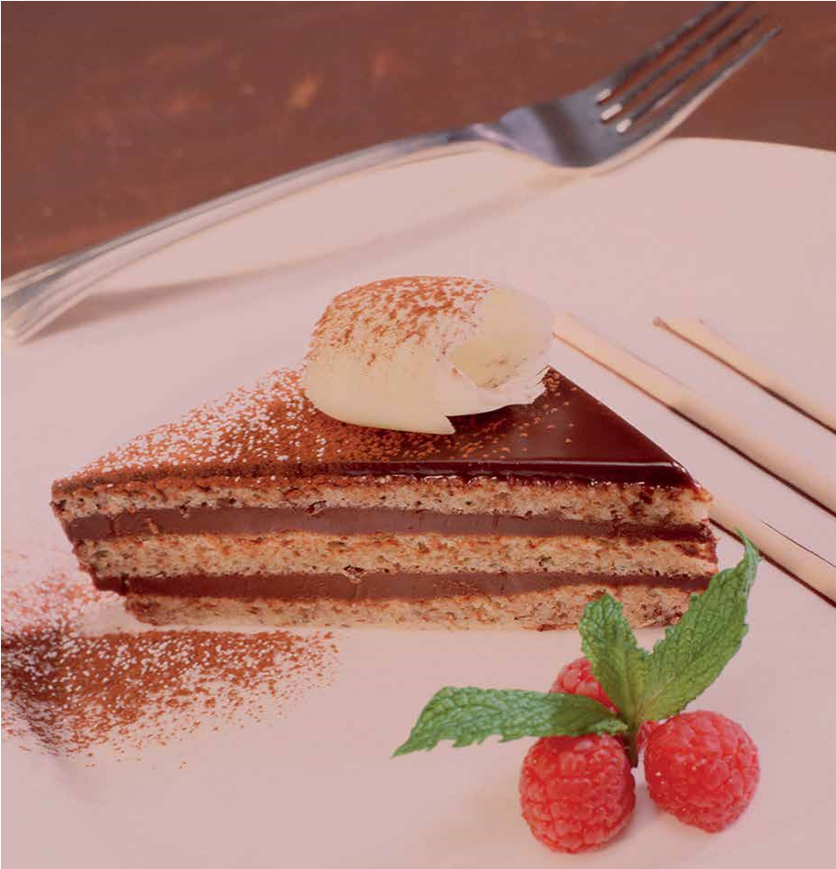

**© Pearson Education Limited 2016**